Foreword
This system is an operational management system.
This system is proposed and drafted by the Technology Innovation Department.
The Technology Innovation Department shall be responsible for the interpretation of this system.

1 Scope
This document specifies the process: after the completion of tooling planning and tooling budget approval, the user unit shall submit a Tooling Application Form, formulate tooling technical specifications, and complete the process review of the tooling technical specifications, ultimately meeting the application requirements and budget requirements proposed by the user unit. By establishing a process for the selection and application of tooling, it is used to standardize the application and approval procedures of tooling.
This procedure applies to all projects.
This procedure is formulated in accordance with the requirements of GLG 1407.
2 Normative References
The following documents are indispensable for the application of this document. For referenced documents with a specified date and/or edition, only the version with the specified date and/or edition shall apply to this document. For referenced documents without a specified date and/or edition, the latest version (including all amendment sheets) shall apply to this document.
GLG 1407 Rules for Tooling and Tool Management
3 Forms
3.1 Specified Forms
• FM 1407-50 Tooling Application Form
• FM 1407-46 Template/Data Set Application Form
3.2 Referenced Forms
None
4 Terms and Definitions
4.1 Standard Tooling
A rigid entity that reflects the geometric shape and dimensions of certain parts of a product at a 1:1 actual scale. It serves as an analog standard for manufacturing, inspection, and coordination of production tooling, and is an important basis for ensuring dimensional and shape coordination and interchangeability between production tooling and product parts/subassemblies. Examples include standard samples, standard gauges, standard models, joint templates, and auxiliary gauges.

4.2 Production Tooling
Tooling used for manufacturing, assembling, and installing products, such as jigs, precision machining tables, molds, forming dies, drilling jigs, milling fixtures, modular fixtures, inspection fixtures, ground equipment, and test equipment. Among them, Class Ⅱ Tooling includes assembly tooling for main final products, final product inspection fixtures, and reusable lifting equipment; the rest are Class Ⅲ Tooling.

4.3 Template
A dedicated rigid measuring tool manufactured based on mold lines or data, which represents the actual shape of aircraft parts/subassemblies, with marked markings and drilled process holes. Examples include contour templates, cutting/drilling templates, and chemical milling templates.

5 Organizations and Responsibilities

5.1 Tooling User Unit
5.1.1 The compiler of the Tooling Application Form shall be responsible for applying for production tooling and templates, and reviewing the correctness and compliance of the applications for production tooling and templates.

5.2 Technology Innovation Department
5.2.1 The Technical Office shall be responsible for reviewing the compliance, processability, quantity of tooling, and applications for standard tooling.
5.2.2 The Tooling Design Office shall be responsible for reviewing the applicability of tooling.
5.2.3 The Tooling Office shall be responsible for estimating the cost of the applied tooling.
5.2.4 The Tooling Office shall be responsible for estimating the manufacturing cycle of the tooling.

6 Requirements

6.1 Compliance Management Requirements
None

6.2 Risk Management Requirements
None

6.3 Tooling Application Management Requirements
6.3.1 The application for tooling (including efficiency tooling) shall use Form FM 1407-50, and the application for templates shall use Form FM 1407-46.
6.3.2 For Tooling Application Forms marked with "Buyer-Controlled Tooling (referred to as Controlled Tooling)", tooling technicians and tooling designers shall verify the controlled tooling catalog. In subsequent processes such as tooling design, manufacturing, delivery, and verification, they shall organize all units to implement customer requirements in accordance with customer documents, including design review, selection of customer inspection points for manufacturing process procedures, customer inspection, production verification registration, tooling deactivation registration, tooling scrapping approval, and other relevant customer requirements.
6.3.3 If the tooling/templates for left and right parts of a product cannot be shared, separate Tooling/Template Application Forms shall be submitted respectively.
6.3.4 Tooling/Template Application Forms shall be managed by edition, numbered in sequence as A, B, C... (I, O, Q, S, X, Z are not allowed). The first application shall be Edition A. When a Tooling/Template Application Form needs to be revised, the edition shall be upgraded, and the approval route for the upgraded form shall be the same as that of the original version. All editions of the Tooling Application Form shall be valid simultaneously; after the new version of the Template Application Form is approved and takes effect, the original version shall be invalidated. When applying for tooling, the edition of the engineering digital model shall be recorded after the model.
6.3.5 If tooling needs to be revised due to changes in aircraft engineering drawings, process methods, or other reasons, a Tooling Application Form shall be prepared. In the "Technical Requirements" column, the reasons and basis for the revision, the page numbers of the revised tooling drawings, the content of the revised parts, the structure form shall be specified, and a simplified diagram shall be attached. For tooling revisions caused by changes in aircraft engineering drawings, the part number, edition, and other contents of the revised product shall be listed.
6.3.6 To ensure that the technical requirements for tooling edition upgrade are comprehensive, if the previous edition upgrade of the tooling has been finalized but not completed, no new application for tooling edition upgrade shall be submitted.
6.3.7 If the previous edition upgrade of the tooling has not been finalized and signed, and the applicant from the user unit finds that the technical requirements need to be revised or added, a new application may be submitted. The technical specifications shall clearly state that the edition upgrade shall be merged with the previous application, and the requirements for revising the previous changes shall be put forward.
6.3.8 If the tooling needs to be canceled because the commercial contract has not been signed, the tooling variety list shall be revised first, then an application for tooling edition upgrade shall be submitted. The technical specifications shall clearly state the reasons for cancellation and the description of canceling tooling manufacturing. For tooling for which a manufacturing contract has been signed, the process engineer of the user unit shall submit an application for contract cancellation.
6.3.9 If the proposed tooling requirements need to be revised due to reasons such as adjustment of workshop assembly plan, adjustment of production rate, failure to remove the product from the shelf, tooling manufacturing, etc., the demander shall submit a higher-level application, and the revision shall be approved by the director of the Tooling Office.
6.3.10 During the development phase of a new aircraft, before applying for tooling, the project team shall jointly study the process plan. After the plan is determined, the user unit shall prepare the Tooling Application Form.
6.3.11 For newly manufactured tooling, the quality assurance period of the corresponding tooling shall be specified in the Tooling Application Form. The quality assurance period for assembly tooling is 30 aircraft units, and the quality assurance period for part tooling is 3 batches. If the quality assurance period is less than 1 year, it shall be specified as 1 year.
6.3.12 When submitting an application for new tooling or tooling edition upgrade, the tooling proposer/user unit shall fully consider the necessity and feasibility of the proposed requirements, as well as the application approval time (generally no more than 7 days), contract signing time (generally no more than 40 days), tooling manufacturing time (which varies according to specific work hours and can be consulted with the Tooling Office), and whether the on-site process layout has been approved, the time for site clearance and product removal from the shelf. For part tooling, the assembly units and demand time of the parts shall be fully considered.

7 Process

7.1 Tooling Application Management Process

7.1.1 Tooling Application Management Process Diagram

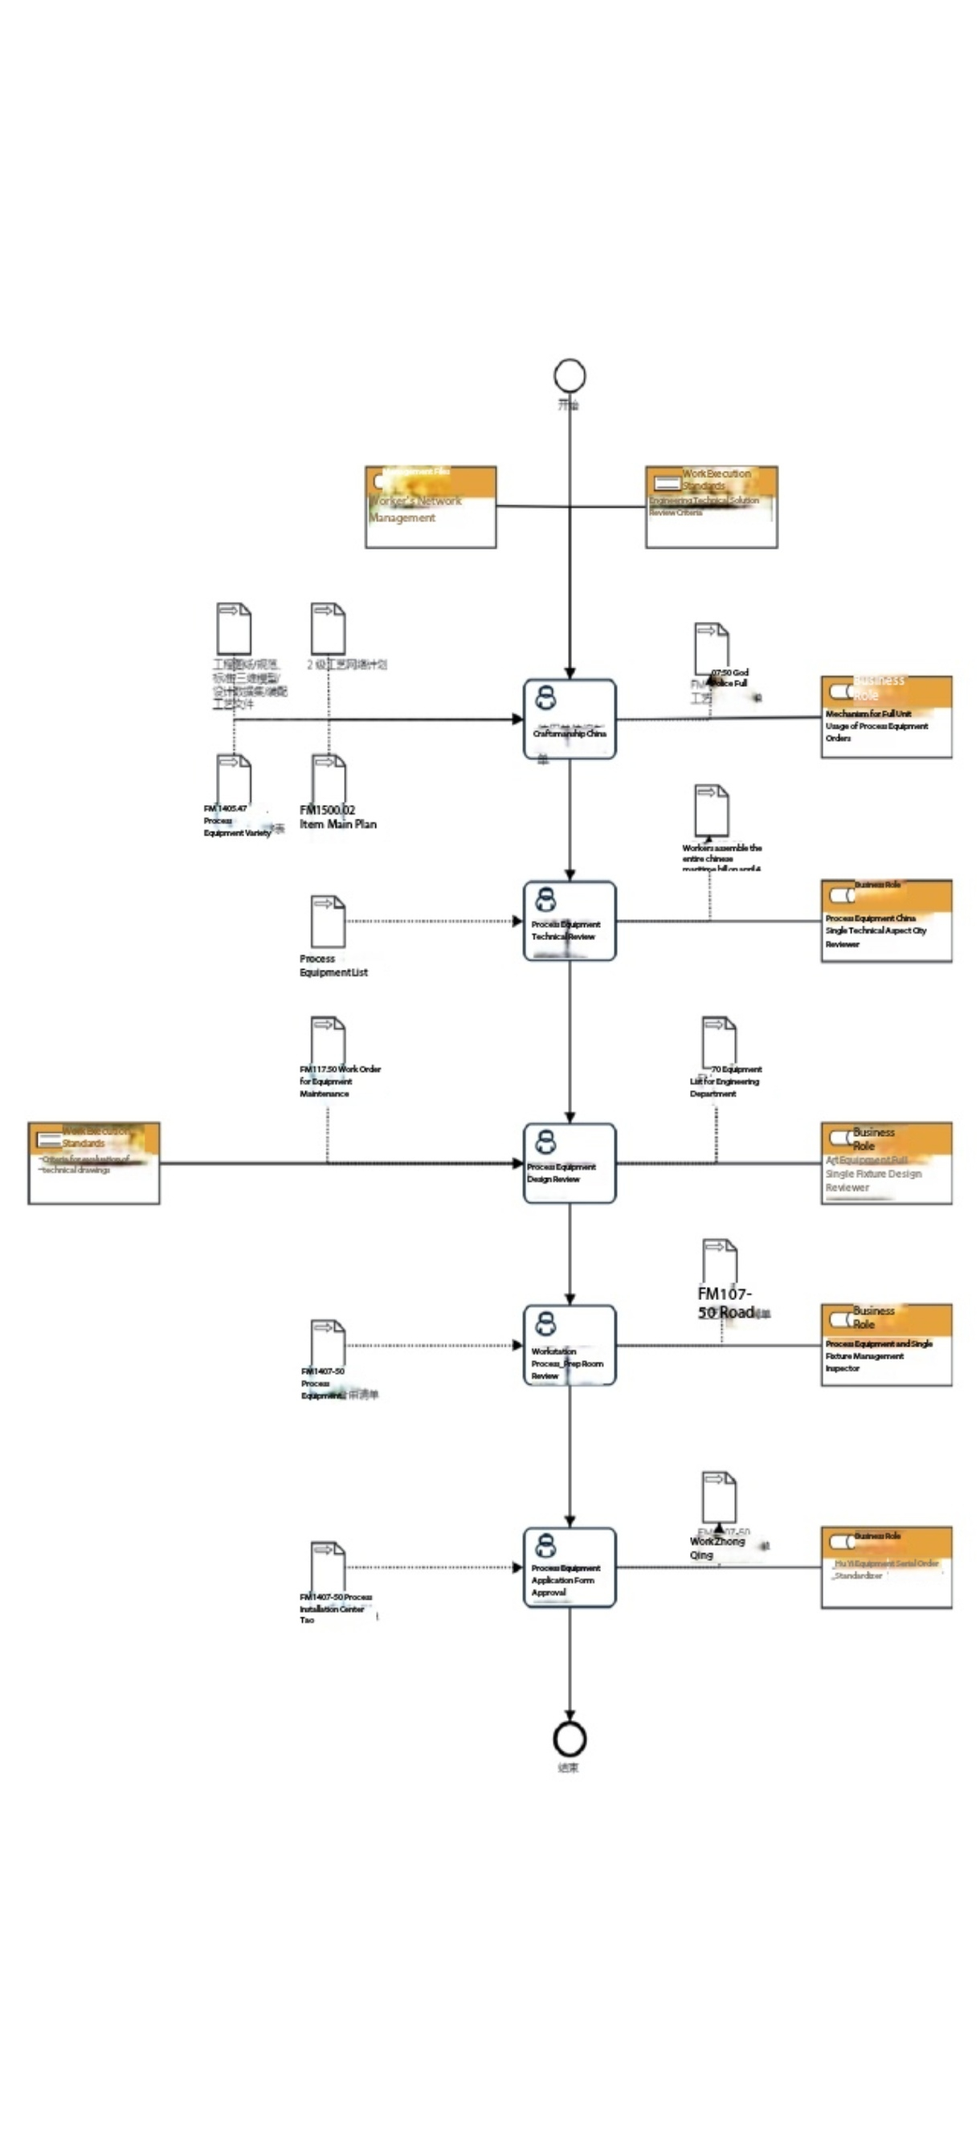

7.1.2 Tooling Application Management Process Description Table

(1) The user unit prepares the Tooling Application Form
Item | Description
Step Description | In accordance with the process network diagram, tooling variety list, project master schedule, engineering drawings/specifications, standards/3D models/design data sets/assembly process documents, complete the formulation of tooling technical specifications, submit the Tooling Application Form, and complete the internal approval of the user unit.
Activity Frequency | 3 days
Process Role | Compiler of the Tooling Application Form (user unit)
Position | Process Engineer, Technician, Director of Technical Office, Deputy Factory Director in Charge of Technology
Inputs | Process network diagram, tooling variety list, project master schedule, engineering drawings/specifications, standards/3D models/design data sets/assembly process documents
Outputs | Tooling Application Form
Compliance Clauses | None
Operation Standards | Tooling Technical Scheme Review Standards
Risks and Countermeasures | None

(2) Review of the tooling technical scheme
Item | Description
Step Description | In accordance with the process network diagram, engineering drawings/specifications, standards/3D models/design data sets/assembly process documents, review the necessity, accuracy, rationality, and comprehensiveness of the technical scheme in the tooling technical specifications of the Tooling Application Form.
Activity Frequency | 2 days
Process Role | Reviewer of the tooling technical scheme
Position | Technician
Inputs | Tooling Application Form
Outputs | Tooling Application Form
Compliance Clauses | None
Operation Standards | None
Risks and Countermeasures | None

(3) Review of tooling design
Item | Description
Step Description | In accordance with the process network diagram, engineering drawings/specifications, standards/3D models/design data sets/assembly process documents, review the design feasibility, rationality, economy, and comprehensiveness of the technical scheme in the tooling technical specifications of the Tooling Application Form.
Activity Frequency | 5 days
Process Role | Reviewer of tooling design
Position | Tooling Designer, Director of Tooling Design Office
Inputs | Tooling Application Form
Outputs | Tooling Application Form
Compliance Clauses | None
Operation Standards | Tooling Technical Scheme Review Standards
Risks and Countermeasures | None

(4) Review of the tooling application by the Tooling Office
Item | Description
Step Description | In accordance with the process network diagram, project master schedule, engineering drawings/specifications, standards/3D models/design data sets/assembly process documents, review the manufacturing feasibility, economy, rationality, and comprehensiveness of the technical scheme in the tooling technical specifications of the Tooling Application Form.
Activity Frequency | 3 days
Process Role | Reviewer of tooling management (Tooling Application Form)
Position | Technical Engineer, Director of Tooling Office
Inputs | Tooling Application Form
Outputs | Tooling Application Form
Compliance Clauses | None
Operation Standards | None
Risks and Countermeasures | None

(5) Approval of the Tooling Application Form
Item | Description
Step Description | Approve the Tooling Application Form in accordance with the process network diagram, tooling variety list, project master schedule, engineering drawings/specifications, standards/3D models/design data sets/assembly process documents.
Activity Frequency | 2 days
Process Role | Approver of the Tooling Application Form
Position | Deputy Chief Process Engineer, Chief Process Engineer
Inputs | Tooling Application Form
Outputs | Tooling Application Form
Compliance Clauses | None
Operation Standards | None
Risks and Countermeasures | None

8 Process Role Responsibility Table
Role | Responsibilities
Compiler of the Tooling Application Form (user unit) | In accordance with the process network diagram, tooling variety list, project master schedule, engineering drawings/specifications, standards/3D models/design data sets/assembly process documents, complete the formulation of tooling technical specifications, submit the Tooling Application Form, and complete the internal approval of the user unit.
Reviewer of the tooling technical scheme | In accordance with the process network diagram, engineering drawings/specifications, standards/3D models/design data sets/assembly process documents, review the necessity, accuracy, rationality, and comprehensiveness of the technical scheme in the tooling technical specifications of the Tooling Application Form.
Reviewer of tooling design | In accordance with the process network diagram, engineering drawings/specifications, standards/3D models/design data sets/assembly process documents, review the design feasibility, rationality, economy, and comprehensiveness of the technical scheme in the tooling technical specifications of the Tooling Application Form.
Reviewer of tooling management (Tooling Application Form) | In accordance with the process network diagram, project master schedule, engineering drawings/specifications, standards/3D models/design data sets/assembly process documents, review the manufacturing feasibility, economy, rationality, and comprehensiveness of the technical scheme in the tooling technical specifications of the Tooling Application Form.
Approver of the Tooling Application Form | Approve the Tooling Application Form in accordance with the process network diagram, tooling variety list, project master schedule, engineering drawings/specifications, standards/3D models/design data sets/assembly process documents.

9 Core Process Performance Indicator Table
None

10 Establish the following management standards to support this procedure
GLB1407020101 Tooling Technical Scheme Review Standards

11 Record Control
The filling and maintenance of relevant records shall be implemented in accordance with the procedure document GLC 231008 Requirements for Quality Record Management.

Appendix A
(Normative)
None

